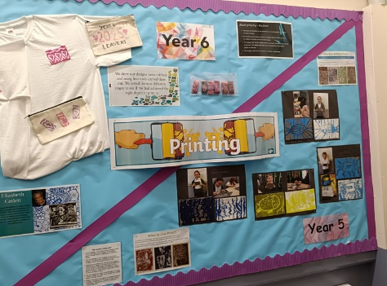
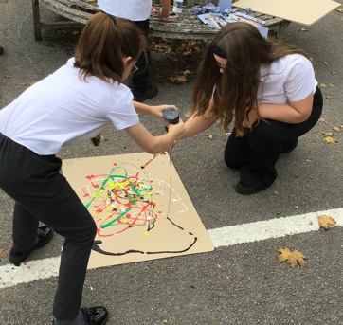
Art and Design
at
Pelsall Village School

INTENT
At Pelsall Village School, art and design are seen as embodying some of the highest forms of creativity. We believe that a high-quality art and design education should engage, inspire, and challenge pupils. Our aim is to equip children with the knowledge and skills to experiment, invent, and create their own works of art, craft, and design. As pupils progress through their education, they should be able to think critically and develop a deeper understanding of both the practical and theoretical aspects of art and design. Additionally, our curriculum helps students understand how art and design reflect and shape our history and contribute to the culture, creativity, and wealth of our nation. This comprehensive approach ensures that our students not only become proficient in creating art but also appreciate its significance in the broader context of our society.
- In our school, we teach Art and Design with the intention of helping children understand the purpose behind their learning, making it more likely for them to retain the knowledge and skills they acquire. Art and Design is taught as an independent subject, focusing on developing specific skills. However, there are occasions when this subject naturally connects with other non-core subjects, and during these times, we make meaningful links to enhance the overall learning experience.
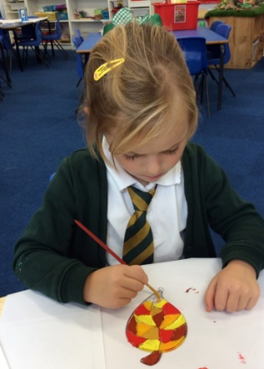
- At Pelsall Village School, it is essential for children to develop their art and design skills as they progress through the school years. This development ensures that they grow to be confident and competent in these areas, preparing them effectively for their next phase of learning. By focusing on art and design, children not only learn to express their creativity but also acquire important skills that will benefit them throughout their educational journey and beyond.

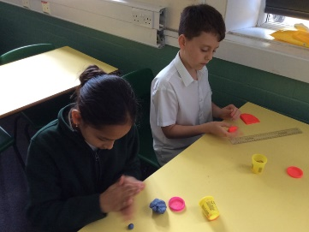
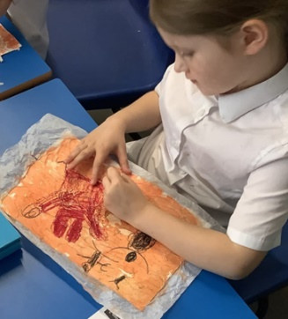
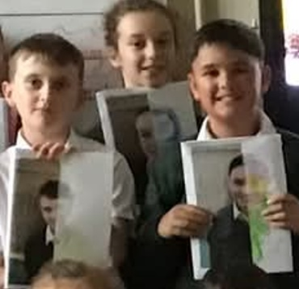

IMPLEMENTATION
- Art and design is coordinated by D.Sadler who has the responsibility to ensure that the contents of the Subject Plans are carried out to the highest possible standards.
- In our curriculum for Art and Design, we primarily deliver the content through stand-alone lessons. Each new topic begins with a focus on key vocabulary to ensure children develop a clear understanding of important terms. This approach helps them grasp fundamental concepts and communicate their ideas effectively throughout their learning journey. By emphasizing vocabulary from the start, we aim to build a solid foundation that enhances their engagement and creativity in every lesson.
- At Pelsall Village School, we make sure that learning about art and design is both fun and engaging by connecting it to various topics, which helps give children a clear purpose in their projects. We introduce them to a wide range of media and study different artists to spark their curiosity and creativity. Our approach encourages children to develop their own unique artistic style, rather than limiting their creative expression, fostering a more personalized and fulfilling learning experience.
- In the Early Years Foundation Stage, Expressive Arts and Design is an essential part of everyday learning for children. This area is explored through shorter, linked topics that span throughout the term, allowing children to immerse themselves in creative activities regularly. As they engage with these topics, children develop important skills, such as understanding colours and mixing them effectively. They also learn to draw and paint with greater precision, gradually including more detail in their artwork. These activities help build the fundamental foundations of their artistic skills, which they continue to develop as they progress through school. By fostering creativity and imagination at an early age, children gain confidence in expressing themselves artistically.
- From years 1 to 6, children learn through an overall topic spanning the half term. Autumn 1 – Artists, Craft makers and Designers, Autumn 2 – Painting Spring 1 – Drawing, Spring 2 – Sculpting, Printing Summer 1 – Art Techniques, Summer 2 – Art and Design for Life

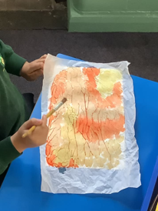
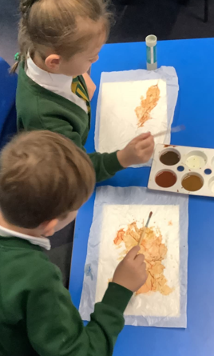
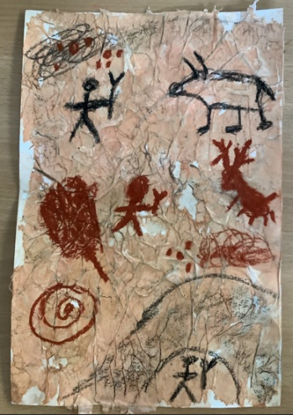

IMPACT
Throughout their time in school, children are introduced to a variety of skills that lay the foundation for their learning journey. These skills are not only important for their academic growth but also help nurture their creativity and personal expression. As they move through the different year groups, they have opportunities to build upon what they have already learned. This ongoing development allows them to refine their creative abilities and discover their unique individual style, ensuring a well-rounded educational experience.
- Sketching/drawing
- Painting
- Art history and the artists
- Sculpting
- Range of media (batik, pastels, oils, acrylic, water colour, charcoal)
- Depth perception perspective
- Shading (light and dark)
- Still life drawing
- Imaginative drawing
Children are also encouraged to enrich their creative flair through clubs provided by the school. These clubs offer a fantastic opportunity for children to explore their interests and talents in a fun and supportive environment. By participating in these activities, students can express themselves creatively while building confidence and their skills. The clubs also help to foster a sense of community and belonging among the students, as they work together on projects and share their achievements. Overall, these creative clubs play a significant role in enhancing the children's educational experience, allowing them to develop new skills and make new friends.


