Physical Education Page2024-2025
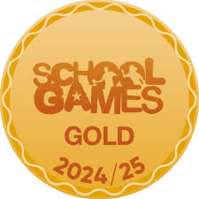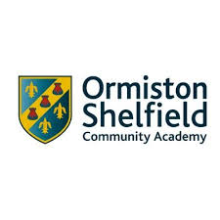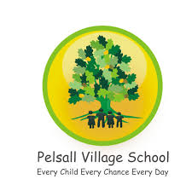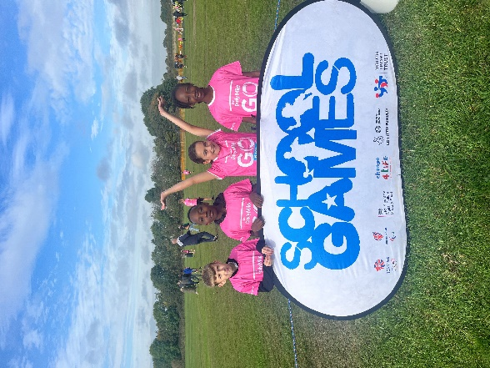
Intent
Pelsall Village school recognises the value of Physical Education (PE). We fully adhere to the aims of the national curriculum for physical education to ensure that all children:
- Develop competence to excel in a broad range of physical activities.
- Are physically active for sustained periods of time
- Engage in competitive sports and activities
- Lead healthy, active lives.

We also endeavour to encourage fair-play and sportsmanship in the sports and fitness we provide at Pelsall Village.
We mostly provide PE as a stand-alone provision where this is more applicable in developing specific skills.
It is important that the children at Pelsall Village school develop their PE skills as they progress through the school so that they are confident and competent in readiness for their next phase of learning.

Implementation

PE is coordinated by Mrs Berry who has the responsibility to ensure that the contents of the subject plan is carried out to the highest possible standard.
It is supported by Our Sports coach Mr Jones (J&J sports) and Mrs Berry who organises the extra curriculum and all inter school competitions.
J&J Sports deliver all our after-school clubs tues-Fri delivering a wide range of sports and activities.

We ensure that the learning in PE is stimulating and exciting by offering extra-curricular activity both in school and further afield, by allowing teachers to learn from our dedicated sports coach to improve all teaching in schools by encouraging teamwork , dedication and fair-play in our lessons.

We actively seek out for other links with other subjects such as dance, cricket, mental health and eating healthy schemes.
We believe our provision encourages children envisage careers such as in athletics, team sports and individual sports. We want the children to know that fitness is also a key to how we feel about ourselves in the adult world.
Our goal is to achieve Platinum school games award as we have achieved Gold for the last four consecutive years.

AUTUMN 1
REC links | Basic Skills, fundamental movements.
Year 1 | Basic Skills, ball skills, throwing and catching.
Year 2 | Basic skills, ball skills, throwing and catching.
Year 3 | Gymnastics, shapes jumps and sequences.
Year 4 | Gymnastics, shapes jumps and sequences.
Year 5 | Benchball/dodgeball, teamwork throwing, catching and strategy.
Year 6 | Benchball/Dodgeball, teamwork, throwing, catching and strategy.



