Religious Education Curriculum at Pelsall Village Primary School
The Intent, Implementation and Impact of our RE Curriculum
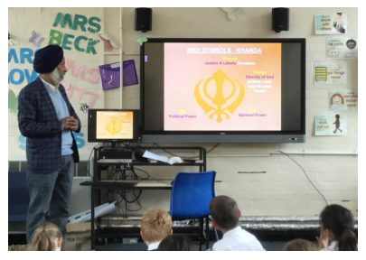
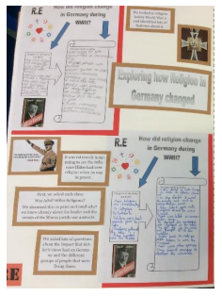
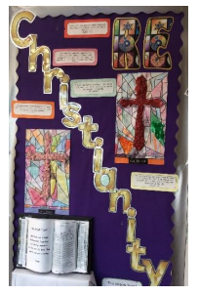

The aim of Religious Education in Walsall is that pupils will know about and understand a range of religions and worldviews. They will express ideas and insights of their own into the significant human questions which religions address, gaining and deploying the skills needed to study religion.
The Walsall Agreed Syllabus Religious Education
Harmony and Diversity 2021-2026

INTENT
At Pelsall Village Primary, we believe that it is important for all our pupils to learn from and about religion, so that they can understand the world around them. The aim of Religious Education in our school is to help children to acquire and develop knowledge and understanding of Christianity and the other principal religions represented in Great Britain; to appreciate the way that religious beliefs shape life and behaviour, develop the ability to make reasoned and informed judgments about religious and moral issues and enhance their spiritual, moral, social and cultural development. Religious Education is taught throughout the school in such a way as to reflect the overall aims, values, and philosophy of the school, through topics such as Justice and Freedom and Heroes/ Heroines in everyday life. It plays an important role, along with all other curriculum areas, particularly PSHE, in promoting social awareness and understanding in our children. We encourage our pupils to ask questions about the world and to reflect on their own beliefs, values and experiences. We include and promote British values, ensuring that children are aware of their rights and responsibilities as UK citizens. Our curriculum is designed to encourage creativity, imagination, enquiry, debate, discussion and independence.

IMPLEMENTATION
We follow the Walsall SACRE Agreed Syllabus for Religious Education as the basis for our curriculum. At Pelsall Village, it has been agreed that having taken into account the requirements and guidelines presented in the Agreed Syllabus, the following religions have been selected for study:

• Christianity
• Islam
• Judaism
• Hinduism
• Buddhism
• Sikhism

From the syllabus it is required that:-

In the Early Years Foundation Stage the learning outcomes are referenced to Christianity and as appropriate to a range of other beliefs and cultures.

• KS1 - Christianity is studied (and two other principal religions in some depth) – Islam and Sikhi
• KS2 – Christianity is studied (and three other principal religions in some depth) –
Sikhi, Hindu and Islam

Subject Skills Progression Plan

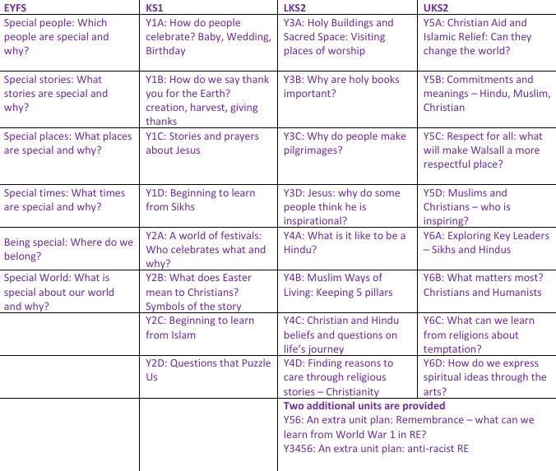

There are no presumptions made as to the religious backgrounds and beliefs and values of the children and the staff. We value the religious background of all members of the school community and hope that this will encourage individuals to share their own experiences with others freely. All religions and their communities are treated with respect and sensitivity and we value the links, which are, and can be made between home, school, and a faith community. We are extremely fortunate that our Chair of Governors, Pastor Stephen Hope, who is a member of our local Evangelical church, regularly visits our school and delivers assemblies to all key stages.

We acknowledge that each religion studied can contribute to the education of all our pupils. We promote teaching in Religious Education that stresses open enquiry and first-hand experiences wherever possible for both staff and children.

IMPACT
The children at Pelsall Village Primary enjoy learning about other religions and why people choose, or choose not to follow a religion. Through their R.E. learning, the children are able to make links between their own lives and those of others in their community and in the wider world, developing an understanding of other people’s cultures and ways of life. As such, R.E. is invaluable in an ever changing and shrinking world.

