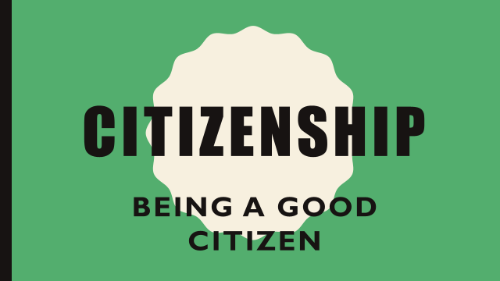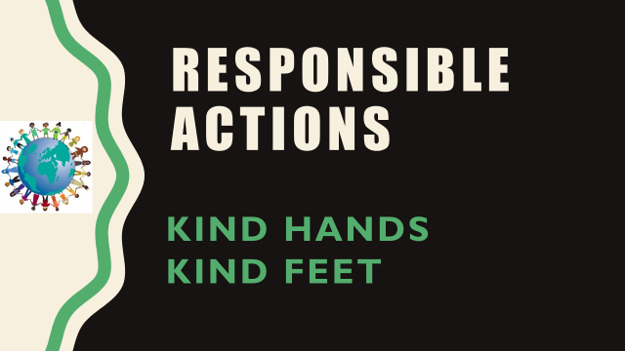
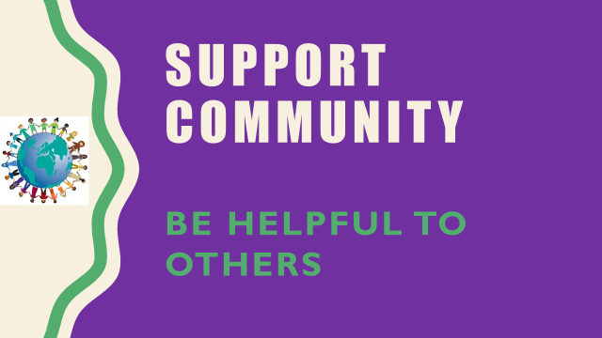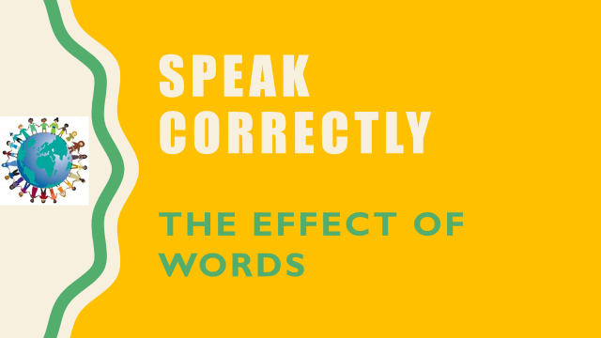
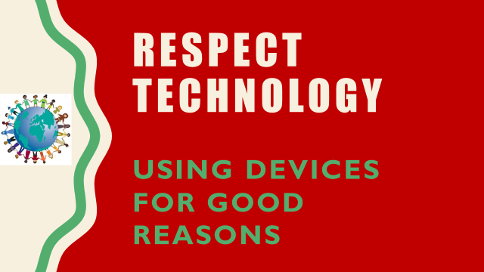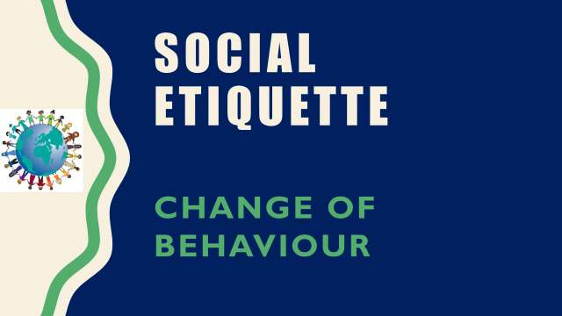
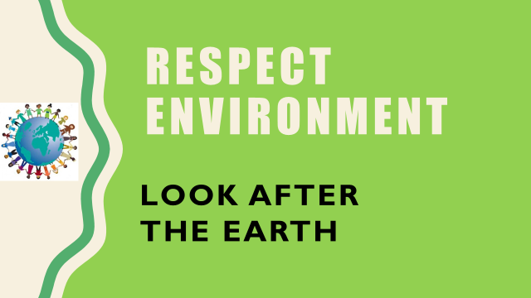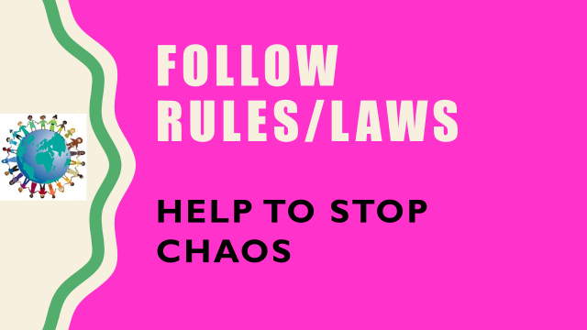
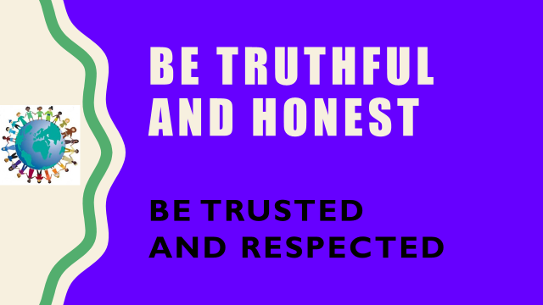
Our 8 behaviours cover all the aspects of becoming a good citizen.

- Responsible Actions – In school we talk about having kind hands and kind feet and personal space. Some children still find it difficult to control their actions. We encourage self-regulation so that the children independently make the right choices about their actions.

- Speak Correctly – Do we always say the right thing? We are working on making children realise that sometimes when we do not say the right things this leads others to use the wrong actions.

- Support Community – This is the idea of having behaviours that show that individuals are part of a team. If we help each other, then together we can make more progress.

- Respect Technology – Children have ready access to technology but educators are rapidly seeing an increase in its misuse. In school we have issues with children’s negative use of Social Media outside of school. Unfortunately the issues often come in to school and can disrupt learning.

- Social Etiquette – This is trying to teach children that our behaviours can and should change depending on ‘where we are’ and ‘who’ we might be speaking to. This doesn’t mean that we have to change as a person.

- Respect Environment – Everyone is now much more aware of their role in caring for the environment. We want our children to understand and show that they care about their own environment because others share it with them.

- Follow Rules/Laws – When children develop in to adults they still have rules and laws to follow. Children need to respect rules/laws and understand that they help to create a safe world.

- Truthful and Honest – Positive morals that will lead to being respected by others in your community. We encourage children to accept that they will make mistakes, but that learning from them is important, and this often starts with being truthful.

