SCIENCE CURRICULUM AT PELSALL VILLAGE SCHOOL
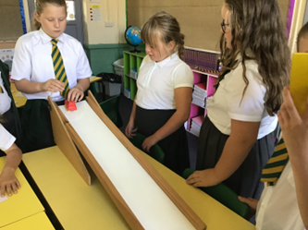
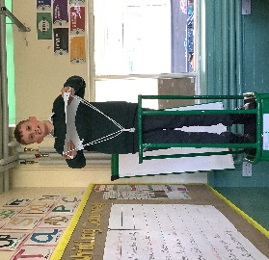
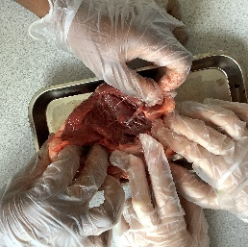

INTENT
At Pelsall Village, our science curriculum is designed to spark curiosity, encourage exploration and develop a deep understanding of the world around us.
Our intent is to:
- Foster curiosity and a love for learning about science through hands-on experiences, investigation and questioning.
- Provide a broad, balanced and progressive curriculum that builds knowledge skills from EYFS to Year 6.
- Develop children’s scientific knowledge and understanding.
- Enable to work scientifically, develop skills in observation, predication and investigation.
- Make science relevant and meaningful.
We believe that by the time children leave our school, they should have a secure foundation in scientific thinking and an appreciation for how science shapes our lives and our world.
IMPLEMENTATION
- Science is coordinated by Miss Foster who has the responsibility to ensure that the contents of the subject are carried out to the highest possible standards.
- Science is taught as a stand-alone subject following the White Rose Scheme of work.
- It is delivered through our challenge system to allow progression throughout the lesson.
- Where possible practical investigation is used to create stimulating and exciting science lessons.
IMPACT
The impact of our science curriculum is that children leave primary school with a secure foundation of scientific knowledge, skills, and understanding. They develop a sense of curiosity and confidence in exploring the world around them, and are able to think critically, ask questions, and make evidence-based conclusions.
Through engaging, hands-on learning and regular opportunities to work scientifically, children:
- Demonstrate strong scientific knowledge across biology, chemistry, and physics.
- Can confidently use scientific vocabulary to explain their thinking and observations.
- Are skilled in investigating, recording, and interpreting scientific enquiries.
- Show a growing ability to ask questions, make predictions, and evaluate evidence.
- Understand the importance of science in everyday life and its relevance to real-world issues such as health, sustainability, and technology.
- Are prepared for future learning in science, with the skills and enthusiasm needed to succeed at secondary level and beyond.
- Develop a positive attitude towards science, seeing it as both meaningful and achievable.

AUTUMN 1
REC links
Year 1 | The human body and Seasonal Changes (autumn)
Year 2 | Animals needs for survival and Humans
Year 3 | Skeletons, Movement and Nutrition and Diet
Year 4 | Group and classify living things
Year 5 | Forces and Spaces
Year 6 | Living things and their habitats

AUTUMN 2
REC links
Year 1 | Materials and Seasonal Changes (winter)
Year 2 | Materials and Plastic
Year 3 | Food waste and Rocks
Year 4 | States of Matter
Year 5 | Global warming
Year 6 | Electricity and Renewable energy

