(SUBJECT) CURRICULUM AT PELSALL VILLAGE SCHOOL
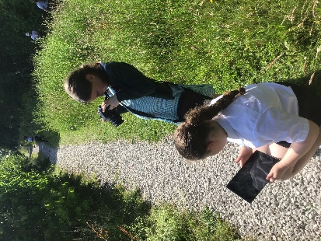
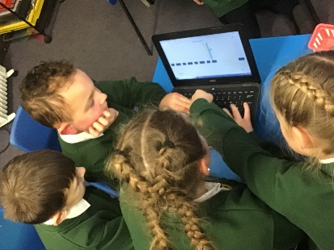
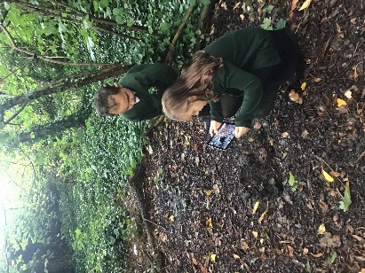

INTENT
At Pelsall Village School, we aim to provide a comprehensive Computing curriculum that equips students with the essential skills and knowledge needed to thrive in an increasingly digital world. Our intent is founded upon the following key principles:
- Digital Literacy: We strive to foster students' confidence in using technology responsibly, safely, and effectively. Our curriculum ensures that all learners develop a robust understanding of the fundamental concepts of computer science, information technology, and digital literacy.
- Creativity and Innovation: We encourage creativity through the integration of Computing across the curriculum. Our intent is to inspire learners to explore and innovate using various technological tools, promoting both individual expression and collaborative projects.
- Problem Solving and Critical Thinking: Our curriculum is designed to cultivate critical thinking and logical reasoning. Through hands-on experiences and challenges, we encourage students to approach problems methodically and creatively.
- Inclusivity: We intend to provide a tailored curriculum that meets the diverse needs of all learners, ensuring equitable access to Computing education. We actively promote an inclusive environment where every child feels encouraged and valued.
- Real-World Application: We aim to connect Computing education with real-world scenarios, enabling students to see the relevance of technology in their daily lives and future careers.

IMPLEMENTATION
To realise our intent, we employ the following strategies in our Computing curriculum:
- Curriculum Design: Our Computing curriculum is structured around the National Curriculum, ensuring it is progressive, challenging, and engaging. We have designed units that focus on core areas like computer science concepts, programming, digital literacy, and online safety.
- Interdisciplinary Integration: Computing skills are embedded across various subjects, allowing students to apply their knowledge in context. For example, students may use coding to create interactive presentations in Science or utilise data handling tools in Maths.
- Hands-On Learning: We prioritise practical, hands-on experiences. This includes using a variety of platforms such as coding software (like Scratch and Python) and hardware (such as robots and microcontrollers) to develop students' skills in programming and computational thinking.
- Professional Development: Staff receive ongoing training in the latest technological developments and teaching strategies for Computing. This ensures that our educators are equipped to deliver inspiring and relevant lessons that reflect current industry standards.
- Assessment and Feedback: We implement formative and summative assessments to monitor progress. Regular feedback is provided to students, allowing them to reflect on their learning and improve their skills continually.
- Parental Engagement: We hope to maintain strong connections with families, providing resources and workshops that empower parents to support their children’s Computing learning at home.

IMPACT
The impact of our Computing curriculum is measured through various indicators:
- Skill Proficiency: Students consistently demonstrate high levels of proficiency in Computing skills across all key stages. Evaluations of students' work show clear progression in their understanding of foundational Computing concepts and practical skills.
- Engagement and Motivation: Pupil surveys indicate a high level of enthusiasm for Computing, with many students expressing a desire to pursue further opportunities in technology. Attendance and participation rates in Computing-related activities and clubs are consistently high.
- Academic Achievement: Our Computing curriculum has a positive correlation with overall academic achievement. Students are well-prepared for subsequent stages of their education, often outperforming national averages in Computing assessments.
- Digital Citizenship: Students exhibit a strong understanding of online safety and digital citizenship, demonstrating responsible behaviour and critical thinking when engaging with technology.
- Community Connections: Feedback from parents and community partners indicates that our students display greater awareness of career opportunities in technology and demonstrate initiative in seeking these pathways.
- Inclusivity and Equity: Our approach to Computing has successfully engaged all pupils, including those with additional needs. We continually strive to eliminate barriers and ensure that every child excels in their Computing journey.
In conclusion, at Pelsall Village School, our intent, implementation, and impact reflect a commitment to delivering an outstanding Computing education that prepares our students for a digital future. We are dedicated to fostering an environment that nurtures creativity, promotes critical thinking, and empowers learners of all backgrounds to succeed in the ever-evolving technological landscape.

AUTUMN 1
REC links | Looking at how quickly our information can get around places via the internet. Using pictures and social media to show the children how many people can see our pictures.
Year 1 | Looking at computing systems and how to use them in different ways. What is a computer and how do we use it? Children will be editing text and learning how to use the computer responsibly.
Year 2 | Computing networks – IT around us. Children will look at technology within school and beyond school explaining how it helps us and how to use it safely.
Year 3 | Computer systems and networks. Children will be looking at different digital devices. They will see how they can change the way we work and how they can be used to share information.
Year 4 | Computer systems and networks – looking at the World Wide Web and how networks work and connect. They will look at the dangers of this but also how this can help us to connect with people.
Year 5 | Computing systems and networks – to recognise the role of computer systems in our lives. Children will look at search engines and how results are selected.
Year 6 | Computing systems and networks – looking at how information is shared on the internet via different forms of online communication and how this can help people work together.

AUTUMN 2
REC links | Using paint to make shapes on the computer or iPads.
Year 1 | Creating media using digital painting. Children will look at the different tools needed to create a painted picture on the computers and compare what this is like as well as painting on paper.
Year 2 | Creating media – digital photography. Looking at what makes a good photography, how pictures can be improved using technology and using tools to change an image.
Year 3 | Creating media using stop from animation. Children will take images using the iPads to create an animation which they will plan and edit with the use of technology.
Year 4 | Creating media with the use of audio production. Children will be looking at how podcasts are created using their own audio to edit and build their audio skills.
Year 5 | Creating media and producing their own video. Children will look at different techniques used to create video. They will then create their own and look at reshooting and editing for their final piece.
Year 6 | Creating media and producing their own web page. Children will need to look at what copyright is for use of images and songs. They will look at the features of a web page and plan their own.

